3.7 Switches and Pushbuttons
This is the simplest way of controlling appearance of some voltage on microcontroller’s input pin. There is also no need for additional explanation of how these components operate.
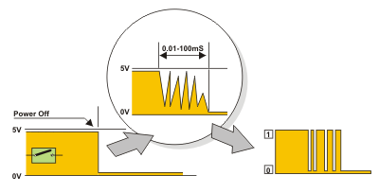
This is about something commonly unnoticeable when using these components in everyday life. It is about contact bounce, a common problem with mechanical switches. If contact switching does not happen so quickly, several consecutive bounces can be noticed prior to maintain stable state. The reasons for this are: vibrations, slight rough spots and dirt. Anyway, this whole process does not last long (a few micro- or milliseconds), but long enough to be registered by the microcontroller. Concerning the pulse counter, error occurs in almost 100% of cases.
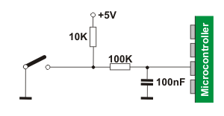
The simplest solution is to connect simple RC circuit which will suppress each quick voltage change. Since the bouncing time is not defined, the values of elements are not strictly determined. In the most cases, the values shown on figure are sufficient.

If complete safety is needed, radical measures should be taken. The circuit (RS flip-flop) changes logic state on its output with the first pulse triggered by contact bounce. Even though this is more expensive solution (SPDT switch), the problem is definitely resolved. Besides, since the condensator is not used, very short pulses can be also registered in this way. In addition to these hardware solutions, a simple software solution is also commonly applied. When a program tests the state of some input pin and finds changes, the check should be done one more time after certain time delay. If the change is confirmed, it means that switch (or pushbutton) has changed its position. The advantages of such solution are: it is free of charge, effects of disturbances are eliminated and it can be adjusted to the worst-quality contacts.

Switch Interfacing with 8051:
In 8051 PORT 1, PORT 2 & PORT 3 have internal 10k Pull-up resistors whereas this Pull-up resistor is absent in PORT 0. Hence PORT 1, 2 & 3 can be directly used to interface a switch whereas we have to use an external 10k pull-up resistor for PORT 0 to be used for switch interfacing or for any other input. Figure 1 shows switch interfacing for PORT 1, 2 & 3. Figure 2 shows switch interfacing to PORT 0.

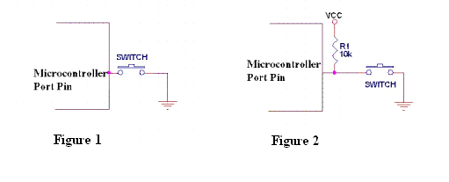
For any pin to be used as an input pin, a HIGH (1) should be written to the pin if the pin will always to be read as LOW.In the above figure, when the switch is not pressed, the 10k resistor provides the current needed for LOGIC 1 and closure of switch provides LOGIC 0 to the controller PIN.

